The 23rd ICMI Study at University of Macau and the Capacity and Network projects (CANP)

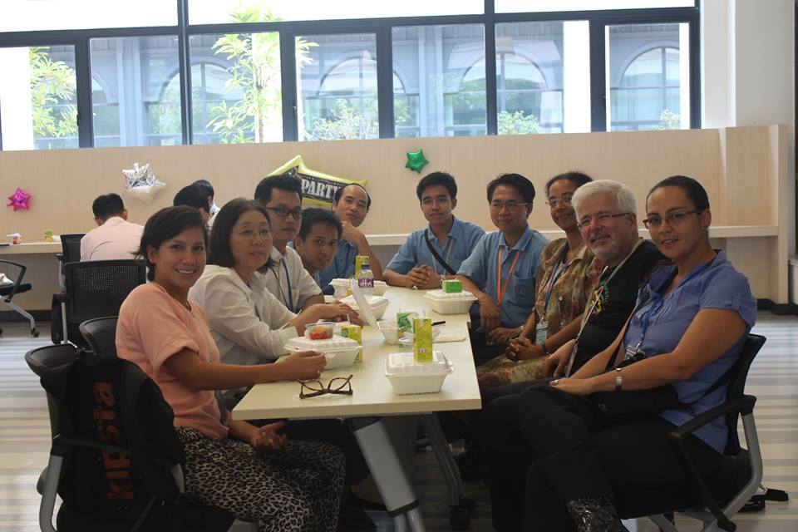

Introduction
The 23rd ICMI Study at University of Macau was not only the first ICMI study that focused on Primary Mathematics but was also the first such study to bring together representatives from the capacity and network projects (CANPs) an initiative of ICMI that focuses on developing countries. By June 2015 when the ICMI Study was held in Macau there had been four CANPs and a fifth was being prepared. This document presents the experience of the various CANP representatives, observers and one of the coordinators during the ICMI Study at University of Macau as well as the impact after the meeting. The first part presents the views of representatives and observers while the second part a description of how the 23rd ICMI study influenced CANP5 in 2016 as described by the general coordinator and chair of the IPC.

Strengthening and linking CANPs
Representatives of each CANP were invited but due to problems with visa the CANP1 representative could not attend and so finally only members of CANP2, CANP3, CANP4 and CANP5 participated in the study thanks to the generous support of the University of Macau and ICMI. The CANP representatives were each assigned to a working group of their choice thus ensuring that other participants had an opportunity to interact and learn about the countries and regions represented by the CANP observers. Moreover, in smaller informal meetings the CANP representatives also networked with each other and had an opportunity to have a formal meeting with Prof. Ferdinando Arzarello (president of ICMI) during which for the first time experiences across CANPs were shared. Hence, one of the major contributions of the 23rd ICMI study was to enable the CANPs to build networks beyond their regions. As a result of connections formed in Macau, a discussion group proposal was submitted and accepted for ICME-13 that will focus on CANPs. Apart from networking, the meeting in Macau enhanced the individual capacity of the representatives that had an effect on their respective institutions, national and regional associations.

CANP2 (Zumbado Castro Marianela, Costa Rica). “The ICMI Study 23 allowed the positioning of the historical moment in which the Costa Rican Educative Reform is located, in relation to the worldwide job that is being done in the area of Numbers. It also allowed to catch a glimpse about the differences in the way of approaching and analyzing this topic in different continents. The representatives of the different CANP, thanks to the auspice of University of Macau, had the opportunity to share learning and experiences about Whole Numbers and the advances in each one of the networks; it was a unique and invaluable experience to strengthen the Worldwide Mathematical Education on the topic.”
CANP3 (Mongkolsery Lin, Cambodia). “Attending ICMI Study 23 is a professionally rewarding experience. It gave me a chance to meet and discuss with many well-known people in the field of mathematics education and also some other CANP representatives. I gained a lot of new ideas from them, not only the knowledge from the group that I attended but also the way of the workshop organized. I learnt that each member in the group had shared their useful experiences related to the topic sessions. I had shared these ideas with my colleagues in Cambodia after return from the conference. We found that some methods are really applicable to the secondary school mathematics in Cambodia. Finally, I have to thank University of Macau that supports me to attend in this great event.”
CANP4 (Veronica Sarungi, Tanzania). “The resources on the website of the University of Macau were shared with members of the working committee of the East African Mathematics Education and Research Network (EAMERN) in their meeting in October. Members of the committee represented various universities and teacher education programmes from the four East African countries of Kenya, Uganda, Tanzania and Rwanda. In addition, the techniques and resources gained during the sessions were used in individual work done with in-service lower primary teachers since promoting early years numeracy is a focus in Tanzania and the region.”
CANP5 (Vallejo Vargas Estela, Peru) “ICMI Study 23 gave me insight on how productive discussions might lead to interesting, valuable products. Observing the kind of work developed in an ICMI Study helped me understand that discussions are important, and moreover it is crucial to lead these discussions towards specific relevant goals which must have been previously set in order not to wander, but focus. This point is what I had in mind when participated in CANP 5. Likewise, I’m sure ICMI Studies (in particular ICMI Study 23) publications can be well used for the professional development of pre-service and in-service teachers, which is directly related to CANP 5 goal, after translating them into Spanish. It was a nice experience to participate in the ICMI Study 23 and the CANP’s observers meeting since I could look at the interest of the ICMI representatives in particular, and the mathematics education community in general, on the search for helping developing countries make progress on the teaching and learning of mathematics.”
There were three (3) additional observers from Cambodia, Lao and Thailand that were countries that formed part of the Third Capacity and Network Project (CANP3). They were supported by the Centre for research in Mathematics Education and Faculty of Education, Khon Kaen University, Thailand.
The three CANP3 observers took video-recordings of various sessions both plenary and in the working group. Apart from meeting with scholars in mathematics and mathematics education, ICMI Study 23 provided an opportunity for each of the observers to learn more about and with participants from other regions. The ICMI Study 23 also provided an opportunity for various CANP representatives to meet and have a round table discussion about their networks and activities. The following are the personal reflections of each of the three observers.
Visa Kim (Cambodia) “At the ICMI Study 23 in the University of Macau on 6th June 2015 during a special meeting, I learned much more about the Capacity and Networking Project (CANP). I met with each CANP representative who reported on what has been done since the CANP meeting in their region such as the output of workshops, issues in the network, and a vision for future and plans for follow-up activities. During the meeting, Prof. Mongkolsery mentioned about the next follow-up activity for CANP3 members in November 2015 in Thailand. I would like to deeply thank the opportunity to be a part of the CANP and to join the ICMI Study 23.
Chanhpheng Phommaphasouk (Lao PDR) “I’m working at Khangkhai Teacher Training College, Pek District, Xiengkhouang Province, Laos PDR. This was my first time to participate in an ICMI Study conference. I was a representative from Laos PDR and part of the “the Great Mekong Region” group. I learnt from scholars from different countries shared experiences and knowledge of outstanding experts in mathematics education in primary education including future topics for research. Throughout the conference, I participated in many sessions and also listened to lectures from mathematicians, mathematics educators that were all useful for me. During the brief round table discussion of all CANP observers, participants from Asia, Africa and Latin America shared experience of cooperating in each region and also the President of ICMI Professor Ferdinando Arzarello suggested how to continue collaboration in each region. ”.
Weerasuk Kanauan (Thailand) “I am a doctoral student from Thailand. I got the opportunity to participate in the ICMI Study 23 Conference at the University of Macau as an observer and CANP representative. I am proud to have met with scholars whose name and works I had previously encountered in seminars and academic reading. I learned about the research in Mathematics Education from several countries and also shared experience about the way to enhance mathematics education with members from other CANP regions. The conference has inspired me to work in the field of Mathematics Education and I hope to join similar studies in the future.

The influence of “The ICMI Study 23: Whole Number Arithmetic” on the activities of CANP 5 (Capacity and Network Project), Lima Peru, 1 – 12 February, 2016.
The following is presented in the words of Yuriko Yamamoto Baldin (chair of IPC, general coordinator of CANP5) who wrote this section. “I acted as the chair of The International Program Committee of the CANP5 held in Lima, Peru, from 01 to 12 February 12, 2016. The event has brought together mathematicians, mathematics educators and representatives of the Ministry of Education from Bolivia, Ecuador, Paraguay and Peru, with the general objective of improving the quality of mathematics education in the region and aiming at the constitution of a network of collaborators to get through this objective.
Among the leading themes selected for discussion works of the CANP5, the issue of teacher education - initial and continued has had the main focus, for it raises the attention of all the participants for the implication to other themes. The national reports elaborated and presented by the country delegations to support the discussions were right on the education of teachers, in which the needs of discussing the important segment of the primary education, especially about the arithmetic literacy, were appointed as a concern of the countries in that region.
I participated in the ICMI Study 23 Conference as a contributor to the Working Group 5 with an article about a professional development course in Brazil at primary level, with focus on the arithmetic of whole numbers. Therefore, participating in the Study 23, sharing the experiences and the knowledge of the outstanding experts in the mathematics education in primary education was a real privilege that helped me to execute the scientific program of CANP5 with deeper perspectives. The generosity of the University of Macau has supported the participation of the CANP observers from CANP 2 to 5 in the works of the conference as well as in a special CANP meeting coordinated by the president of ICMI, professor Ferdinando Arzarello. I am quite sure that this experience was definitive for the CANP 2, 3 and 4 representatives to consolidate the works in their networks, and surely to the representative of CANP5 to make her contribution during the CANP5 the most profitable and meaningful.
Since one of the objectives of the CANP5 constituted in the developments of adequate teaching materials to support the teacher education of elementary level, I am confident that the freshly constituted network of CANP5 will benefit from the ICMI STUDY 23 right for its moves in the near future. I express my gratitude to the coordinators of ICMI Study 23, Mariolina Bartolini-Bussi and Sun Xuhua, for their reporting the Study in ICME13 with mentions to the CANP activities, so giving visibility to the networking efforts of developing countries on their way to improve the mathematics education from early years.”

Conclusion
To conclude, CANP representatives and observers have their gratitude for being invited and supported to attend the ICMI Study 23 at the University of Macau that provided them with an intellectually enriching and inspiring experience that would have a far-reaching effect. Hopefully, the interaction of CANP representatives has also enriched this unique ICMI Study just as it has had a positive impact on CANP5, which took place after the meeting in Macau. In summary, through the generosity of the University of Macau , the Education and Youth Affairs Bureau, Macau SAR (DSEJ; 澳門特別行政區教育暨青年局), and ICMI, the 23rd ICMI study expanded what was started in individual CANPs; namely to enhance capacity and promote networks with the ultimate goal of improving mathematics education.

